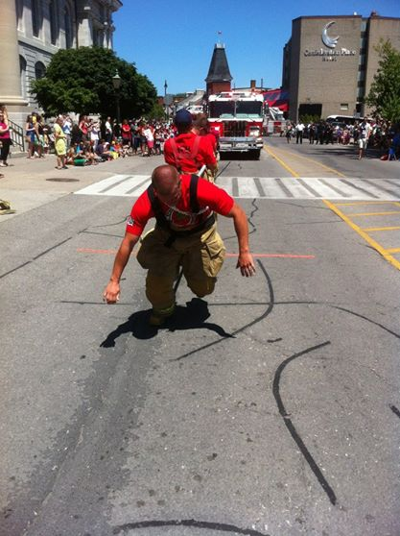

# Team Registration

For more information, visit

**www.epilepsyresource.org/pulltogether2014**  
or email **pulltogether@epilepsyresource.org**





**Participant Information**

The Epilepsy and Seizure Disorder Resource Centre is a non-profit charitable organization dedicated to improving the quality of life for those affected by epilepsy and seizure disorders. We provide support, education, and advocacy services for those affected by epilepsy, and are a community resource for epilepsy education and awareness in Kingston, Frontenac, Lennox & Addington, and Leeds & Grenville. Epilepsy affects 1 in 100 Canadians. Thus, approximately 3,000 people in these areas are living with epilepsy, with many more individuals affected through family, friends, and co-workers.

With goals of raising funds and awareness, the Epilepsy and Seizure Disorder Resource Centre is excited to host our **second annual Fire Truck Pull, *Pull Together for Epilepsy!*** on **Sunday, July 20th, 2014.** We would like to thank you for your interest in participating! Please be sure to acknowledge our team requirements.

**Event Details**

**Date:** Sunday, July 20th, 2014  
**Time:** 11:30am-3:00pm

Registration: 11:30am-12:45pm

Competition starts at 1pm  
**Location:** In front of Kingston City Hall (216 Ontario Street)

**Team Requirements**

1. Maximum of **8 participants per team**.
2. Each participant must be **18+ years of age.**
3. On average, each member should raise **approximately $100** to reach the suggested **team entry goal of $800.**
4. Each team **MUST** have a team name and spirited theme!
5. Each participant must fill out a **waiver form** and **emergency contact form.**
6. Each participant must bring their strength and energy the day of….to pull the Fire Truck, of course!

**The Competition**

There will be 4 different Category Awards.

1. The Overall Event Winner: combination of best pull time and most funds raised
2. The Fastest Pull
3. The Most Money Raised
4. The Best Team Spirit

**Fundraising Tips**

1. **Set a goal and start early**
2. **Tell your story**

* What are you fundraising for?
* Why is this cause important to you?
* How will donations be used? (See attached info sheet about epilepsy and the resource centre)

1. **Make use of social media**

* Facebook, Twitter, Instagram

1. **Make use of an online fundraising page to make donating easier!** (see Team Contact Information form for more information)
2. **Set small (but challenging) weekly fundraising targets**
3. **Get creative!**

* Host a party, collect your spare change for a month, update your email signature with donation information

1. **Send a personalized thank you to your donors**

For more information on the Fire Truck Pull, raising funds, or information on epilepsy, please contact the Epilepsy Resource Centre at 613-542-6222, or email Kaitlin Juraschka at pulltogether@epilepsyresource.org



**Team Contact Information:**

|  |  |
| --- | --- |
| **Team Name**: |  |
|  |  |
| **Team Captain:** |  |

Please select a Team Captain, who will be the primary contact for the Fire Truck Pull.

Please fill in the names of the members of your team.

|  |  |  |
| --- | --- | --- |
| **Name** | **Email** | **Phone Number** |
|  |  |  |
|  |  |  |
|  |  |  |
|  |  |  |
|  |  |  |
|  |  |  |
|  |  |  |
|  |  |  |

If your team would like to use online donation as a method for collecting pledges, please send the following information to Kaitlin Juraschka at [pulltogether@epilepsyresource.org](mailto:pulltogether@epilepsyresource.org).

1. Team Leader’s email address
2. Team bio (short paragraph- Why is your team participating in this event?, What do you hope to accomplish?, and any other fun facts you would like to include)
3. Would you like to have each donation (amount/donor name) displayed on your team page?
4. Team Picture/Logo (optional)



**Registration**

|  |  |  |  |
| --- | --- | --- | --- |
| **Last Name:** |  | **First Name:** |  |
| **Address:** |  | **Postal Code:** |  |
| **Phone:** |  | **Email:** |  |

***Please Don’t Forget to Sign the Waiver!***

The Epilepsy and Seizure Disorder Resource Centre of Southeastern Ontario, event sponsors, volunteers and organizers accepting this entry, hereby for myself, my heirs, executors and administrators waive and release any and all rights and claims for damages sustained by me as a result of this event, for any cause whatsoever including negligence. It is expressly understood by the undersigned that this *PULL* is entered into at the sole risk of the undersigned and that the organizers and sponsors of the event are exempt from liability for any and all damages sustained and all injury and loss, including personal and property loss arising from any cause whatsoever, including negligence. I warrant that I am physically fit to participate in this event. I hereby recognize that my photograph, electronic image and/or video image may be captured during this event. I give permission to the organizers and their volunteers to use these images through any media at any point in time. I assign and transfer the organizers any and all rights, including copyright.

I acknowledge having read, understood and agreed to the above waiver, release and indemnity. All participants must be 18+ years old.

**Signature:** **Date:** Click here to enter a date.



Pledge Form

|  |  |  |  |
| --- | --- | --- | --- |
| Team Name: |  | Individual’s Name: |  |
|  |  |  |  |
| Email: |  | Phone Number: |  |

All money raised by this participant goes towards supporting people in our community with epilepsy.

Charitable receipts will be issues for pledges of $20 or more.

|  |  |  |  |  |
| --- | --- | --- | --- | --- |
| **Name** | **Address** | **Postal Code** | **Pledge**  **Amount** | **Cash or**  **cheque** |
|  |  |  |  |  |
|  |  |  |  |  |
|  |  |  |  |  |
|  |  |  |  |  |
|  |  |  |  |  |
|  |  |  |  |  |

|  |  |  |  |  |
| --- | --- | --- | --- | --- |
| **Name** | **Address** | **Postal Code** | **Pledge**  **Amount** | **Cash or**  **cheque** |
|  |  |  |  |  |
|  |  |  |  |  |
|  |  |  |  |  |
|  |  |  |  |  |
|  |  |  |  |  |
|  |  |  |  |  |
|  |  |  |  |  |
|  |  |  |  |  |
|  |  |  |  |  |
|  |  |  |  |  |
|  |  |  |  |  |
|  |  |  |  |  |
|  |  |  |  |  |

*Please make all cheques payable to the* ***Epilepsy Resource Centre***